Truncated Pyramidal Polyhedra

Definition
# Source: AI Source: Provided by: [Data Path: Persons Table -> ID Column: 1, Name_En Column: Motasem Essam] -> From: [ChatGPT] on [7/25/2026]
Truncated Pyramidal Polyhedra are three-dimensional polyhedra formed by cutting off the apex or other portions of pyramidal polyhedra using planes.
The truncation process modifies the original faces, edges, and vertices while creating new polygonal faces.
These solids retain geometric features derived from their original pyramidal structures.

Types of Truncated Pyramidal Polyhedra
# Source: AI Source: Provided by: [Data Path: Persons Table -> ID Column: 1, Name_En Column: Motasem Essam] -> From: [ChatGPT] on [7/25/2026]
The following examples are listed in your source document:
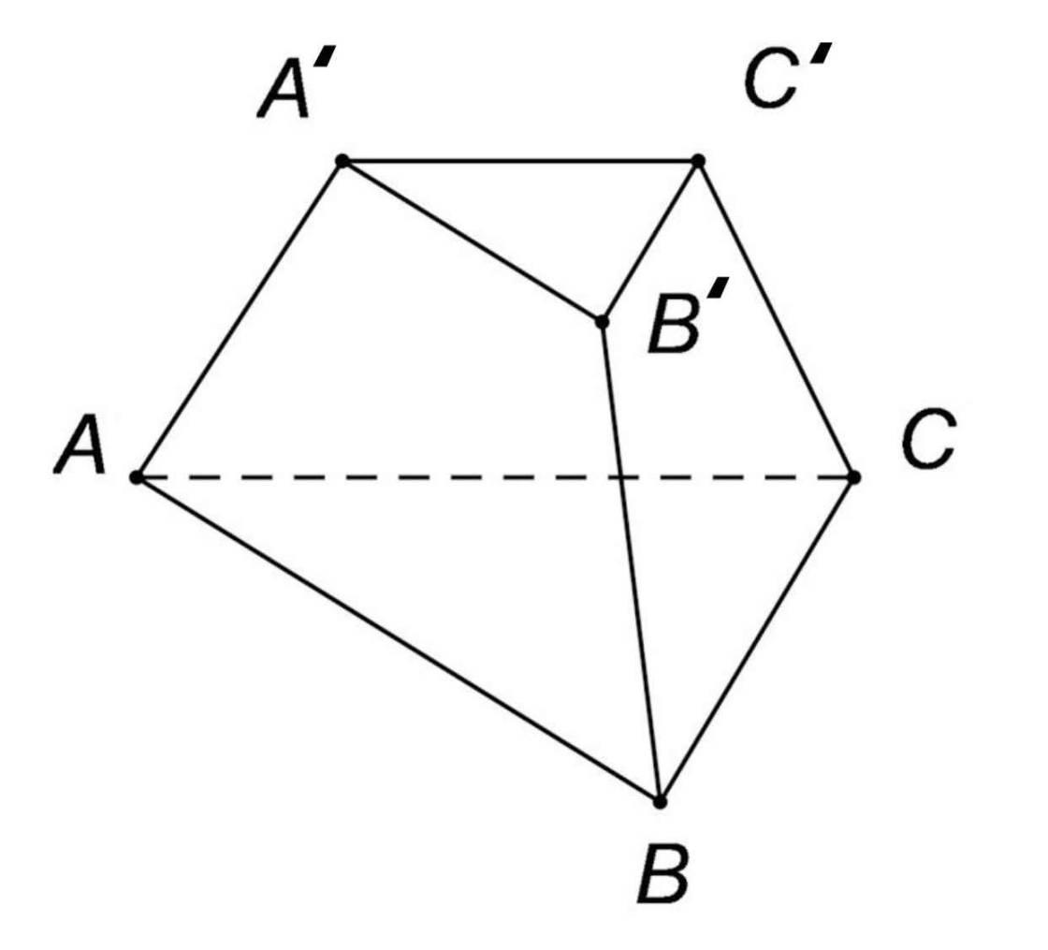

Truncated Triangular Pyramid
# Source: AI Source: Provided by: [Data Path: Persons Table -> ID Column: 1, Name_En Column: Motasem Essam] -> From: [ChatGPT] on [7/25/2026]
Formed by cutting off the apex or other portions of a triangular pyramid.
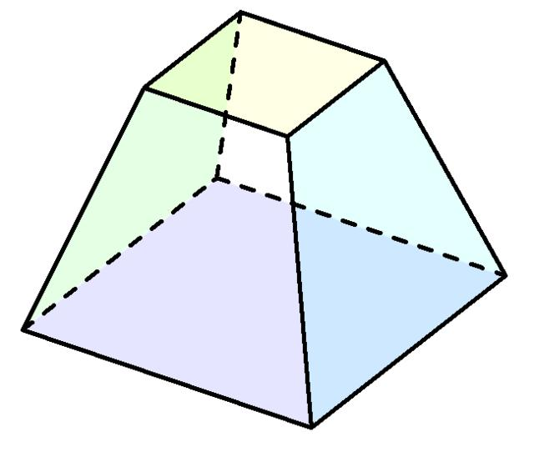

Truncated Square Pyramid
# Source: AI Source: Provided by: [Data Path: Persons Table -> ID Column: 1, Name_En Column: Motasem Essam] -> From: [ChatGPT] on [7/25/2026]
Formed by cutting off the apex or other portions of a square pyramid.
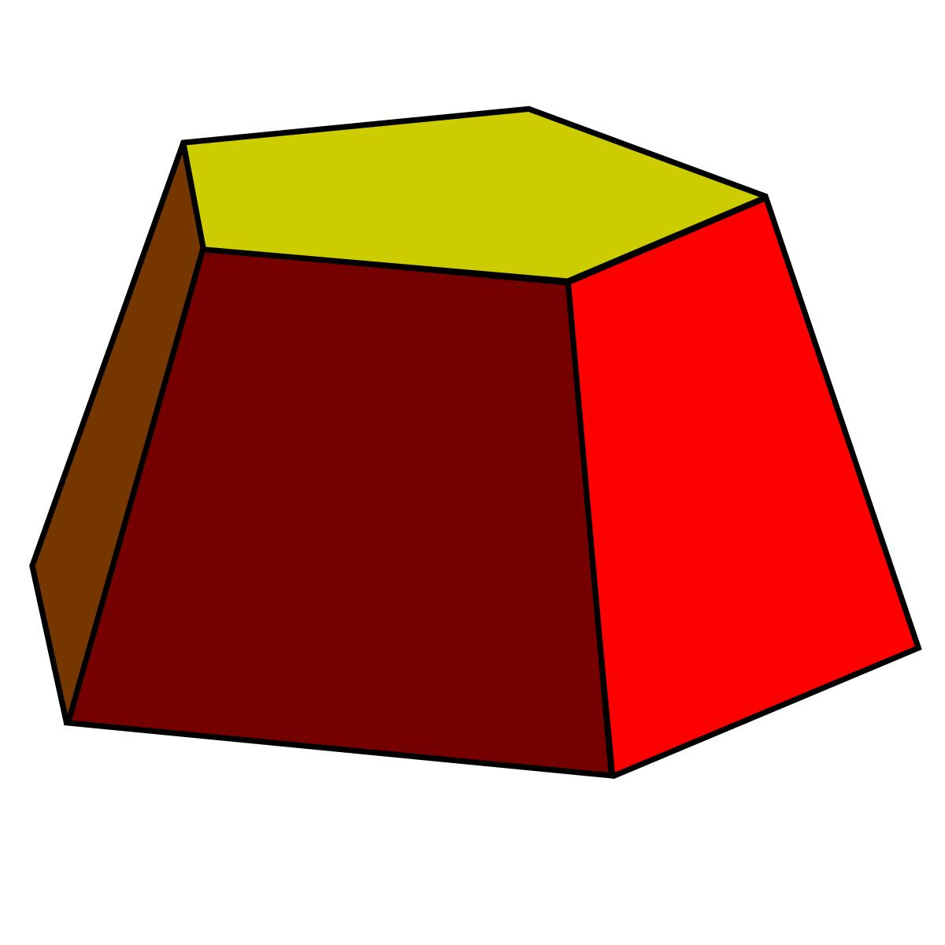

Truncated Pentagonal Pyramid
# Source: AI Source: Provided by: [Data Path: Persons Table -> ID Column: 1, Name_En Column: Motasem Essam] -> From: [ChatGPT] on [7/25/2026]
Formed by cutting off the apex or other portions of a pentagonal pyramid.
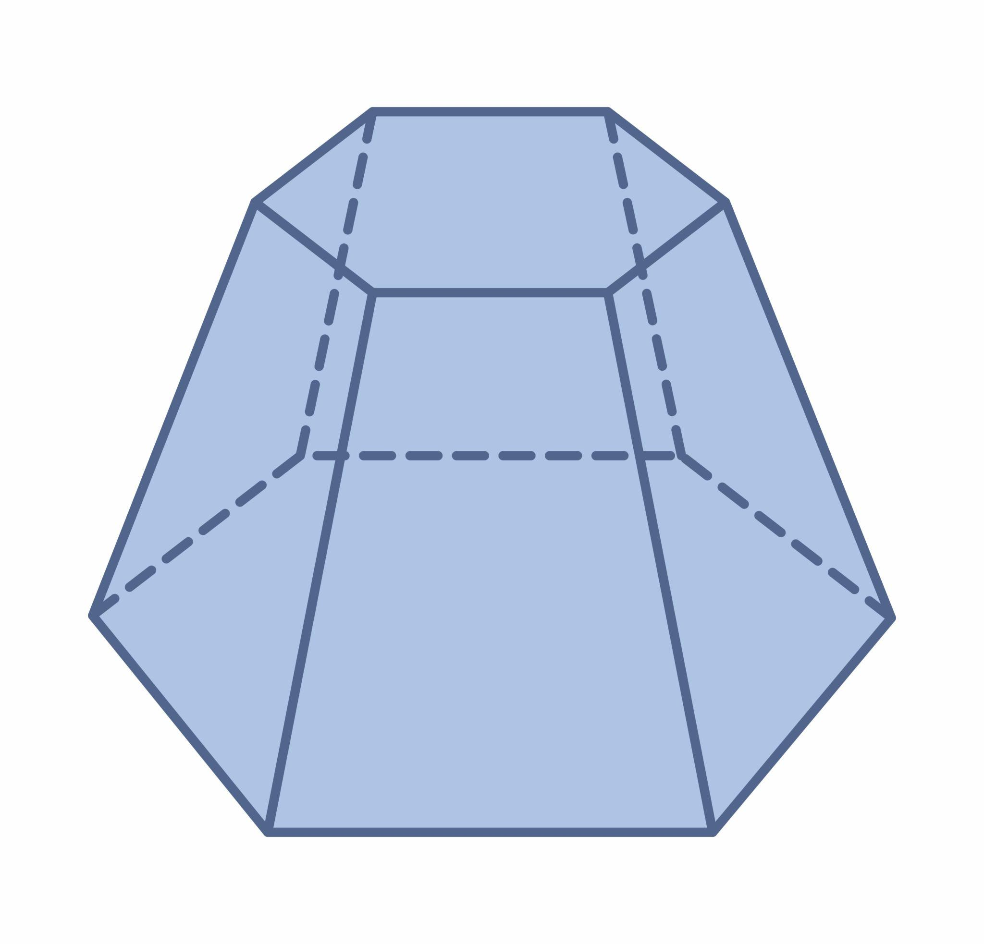

Truncated Hexagonal Pyramid
# Source: AI Source: Provided by: [Data Path: Persons Table -> ID Column: 1, Name_En Column: Motasem Essam] -> From: [ChatGPT] on [7/25/2026]
Formed by cutting off the apex or other portions of a hexagonal pyramid.

Geometric Characteristics
# Source: AI Source: Provided by: [Data Path: Persons Table -> ID Column: 1, Name_En Column: Motasem Essam] -> From: [ChatGPT] on [7/25/2026]
Truncated pyramidal polyhedra generally have the following characteristics:
- Original Base: The polygonal base inherited from the original pyramid.
- Truncation Face: A new polygonal face created by cutting.
- Lateral Faces: The original triangular lateral faces are modified by truncation.
- Original Edges: The edges of the original pyramid are shortened or modified.
- New Edges: Edges created by the intersections of the cutting plane with the original faces.
- Modified Vertices: The original apex or other vertices may be removed.

Key Points
# Source: AI Source: Provided by: [Data Path: Persons Table -> ID Column: 1, Name_En Column: Motasem Essam] -> From: [ChatGPT] on [7/25/2026]
- They originate from pyramidal polyhedra.
- They are formed by cutting off the apex or other portions of the original pyramid.
- Truncation creates new polygonal faces.
- The shape of the new face depends on the cutting plane and the original pyramid.
- Different polygonal bases produce different types of truncated pyramidal polyhedra.

Conclusion
# Source: AI Source: Provided by: [Data Path: Persons Table -> ID Column: 1, Name_En Column: Motasem Essam] -> From: [ChatGPT] on [7/25/2026]
Truncated Pyramidal Polyhedra are modified pyramidal solids formed by removing the apex or other portions of an original pyramid through planar cuts. Their resulting geometric structures depend on the original polygonal base and the applied truncation method.

